Name _____________________________________________________ Period ________________________ Date ________________________

**Online: “The Last Leaf”**

**EQ:** How does "The Last Leaf" story compare with the film?

**Ms. Casarett’s site:** Internet 🡪 [www.rcsdk12.org](http://www.rcsdk12.org) 🡪 Schools/Find Schools 🡪 East High/Submit 🡪 Teachers 🡪 Casarett, V.

**Instructions:**

1. Go to ESOL English; read about ROC Read.
2. Go to ESOL English Last Leaf: Read the lesson plan and instructions.
3. Take the 2 vocabulary quizzes; record your score BEFORE corrections; write the corrections.
4. Watch the film of "The Last Leaf."
5. Complete a Venn diagram that compares the story with the film.
6. Write summary sentences about the similarities and differences.
7. Write your personal response to the story and film: Did you like them? Why, or why not? Which did you prefer? Why?
8. When you have finished this, find and take out a book to read for February break. Write the title, author, and genre.

|  |  |  |
| --- | --- | --- |
| Task | Score | Corrections |
| Last Leaf Vocabulary 1 |  |  |
| Last Leaf Vocabulary 2 |  |  |
| My ROC Read Book Title | Author | Genre |
|  |  |  |

Name _____________________________________________________ Period ________________________ Date ________________________

A Venn diagram helps you compare two things.

Compare the short story and the film.

In the outer circles, write things about them that are different.

In the center circle, write things that are alike.

Summarize the differences and similarities on the lines below.

**“The Last Leaf” by O. Henry**

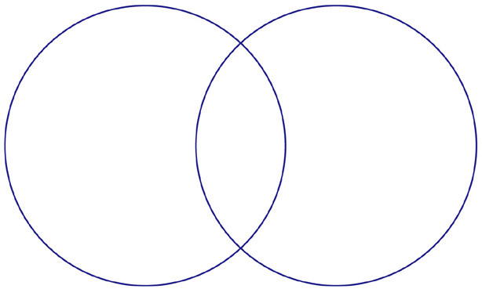

**FILM**

**STORY**

Name _____________________________________________________ Period ________________________ Date ________________________

There are both similarities and differences between the written story and the film of “The Last Leaf.” They are similar because ________________________________________________________________________________________________________________________________________________________________________________________________________________________________________________________________________________________________________________________________________________________________________________

They are different because ________________________________________________________________________________________________________________________________________________________________________________________________________________________________________________________________________________________________________________________________________________________________________________

I prefer the ____________ version because ____________________________________________________________________________________________________________________________________________________________________________________________________________________________________________________________________________________

One connection I made to this story is ____________________________________________________________________________________________________________________________________________________________________________________________________________________________________________________________________________________