Name:_______________________________

Unit 3 Day 1 HW - Angle Practice

**Sketch each angle in standard position. Then find the measure of the reference angle.**

1. 100° 2. 210° 3. −45° 4. −90°

5. −330° 6. −180° 7. −145° 8. 60°

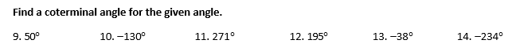

**Find the measure of each angle in standard position.**

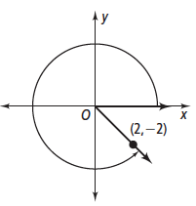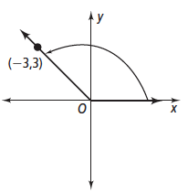15. 16.





17. **Error Analysis** Your classmate believes that the angle shown below measures −225°. What error did your classmate make? What is the correct measure of the angle?

