Lesson 9: Trigonometric Identities

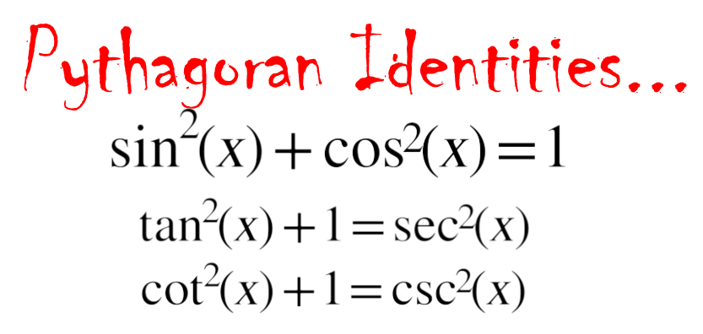

Learning Targets:

* I can use trigonometric identities to simplify trigonometric expressions.
* I can use trigonometric identities to find the value of trigonometric functions.

|  |  |  |
| --- | --- | --- |
|  | **Side Ratio** | **Reciprocal Identities $\left(\frac{1}{???}\right)$** |
| $$csc x$$ |  |  |
| $$sec x$$ |  |  |
| $$cot x$$ |  |  |

Quotient Identities

tan x =

and

cot x =

Directions: Use the reciprocal and quotient identities to simplify the expressions below.

Ex1: $cscxtanxcosx$ Ex2: $\cos^{2}xsecxcscx$ Ex3: $\frac{sinxsecx}{tanx}$



You try

Ex1: $sinxsecxcotx$ Ex2: $\sin^{2}xsecxcscx$ Ex3: $tanxsecxcosx$

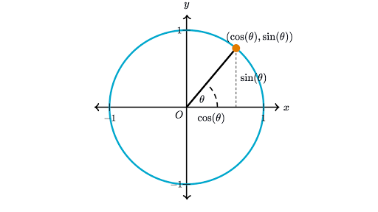Flashback to the Unit Circle

Pythagorean Identity:

Use the Pythagorean Identity to simplify the expressions below:

Ex1. $\frac{\sin^{2}x+\cos^{2}x}{sinx}$ Ex2. $\frac{1-\sin^{2}A}{2cosA}$ Ex3: $\frac{\sin^{2}B}{cosB}+cosB$

**Trigonometric Identities**

**Here are some guidelines:**

1. Work with one side at a time.
2. Try converting all terms to sines and cosines.
3. Look for opportunities to factor or add fractions.

Ex1: $sinxcotx=cosx$ Ex2: $\frac{cscx}{secx}=cotx$

Ex3: $\frac{sinA-1}{cosA}=tanA-secA$ Ex4: $\cot^{2}x=(cscx-1)(cscx+1)$

Ex5: $cotx\left(1-sinx\right)=cotx-cosx$

Using Trigonometric Identities to find Trigonometric Values

Ex 1: Given that $\sin^{2}x+\cos^{2}x=1$ and $sinθ=\frac{-\sqrt{3}}{2}$, what is the value of $cosθ$.

Ex2: Given that $\sin^{2}θ+\cos^{2}θ=1$ and $cosθ=\frac{\sqrt{2}}{2}$, what is the value of $tanθ$.