Name __________________________ Living Environment

Test 9

|  |  |
| --- | --- |
| 1. Evidence that best supports the theory of  biological evolution was obtained from the  (1) investigation of environmental niches  (2) study of fossil records  (3) comparison of the number of cells in organisms  (4) analysis of food chains and food webs  2. In sexually reproducing organisms, mutations can be inherited if they occur in  (1) the egg, only  (2) the sperm, only  (3) any body cell of either the mother or the  father  (4) either the egg or the sperm  3. Compared to a normal body cell, a normal egg cell contains  (1) the same number of chromosomes  (2) half the number of chromosomes  (3) twice the number of chromosomes  (4) four times the number of chromosomes  4 Within which structure of an animal cell does  DNA replication take place?  (1) vacuole (3) nucleus  (2) cell membrane (4) ribosome  5. In order to enter cells and be useful to the body, starch must be  (1) absorbed through the skin  (2) broken down into fats and water  (3) digested into simple sugars  (4) converted to carbon dioxide and ATP | 6. Which event would most likely cause a change in a genetic sequence in an organism?  (1) eating certain foods high in saturated fats  (2) strenuous physical activity  (3) exposure to radiation  (4) a sudden exposure to cooler temperatures  7. If 15% of a DNA sample is made up of thymine, T, what percentage of the sample is made up of cytosine, C?  (1) 15% (3) 70%  (2) 35% (4) 85%  8. Selective breeding is a technique that is used to  (1) give all organisms a chance to reproduce  (2) produce organisms from extinct species  (3) produce offspring with certain desirable  traits  (4) keep farm crops free of all mutations  9. The diagram below represents a technique used in some molecular biology laboratories.    This technique is a type of  (1) chromatography  (2) gel electrophoresis  (3) direct harvesting  (4) genetic engineering |

10. The diagram below represents the bone arrangements in the front limbs of three different species of mammals.



The similarities and differences in these limbs suggest that all three species developed from the same ancestor, but

(1) produced different numbers of offspring

(2) lived in different time periods

(3) adapted to different habitats

(4) migrated to similar habitats

11. The arrows in the diagram below indicate the development of four different varieties of vegetable plants from wild mustard.



Each of these varieties was most likely produced as a result of

(1) asexual reproduction in the wild for many years (3) competition between plants

(2) changes in light availability (4) selective breeding over many generations

12. Four different segments of a DNA molecule are represented below.

**Segment 1 Segment 2 Segment 3 Segment 4**

T–A–G–G–C G–G–T–G–A G–A–T–T–A C–A–A–T–G

A–T–C–C–G C–C–A–C–T C–C–A–A–T G–T–T–A–C

There is an error in the DNA molecule in

(1) segment 1, only (3) segments 2 and 3

(2) segment 3, only (4) segments 2 and 4

**Base your answers to questions 13 through 15 on the information and diagram below and on your knowledge of biology.**

Samples of DNA from an eye-color gene of four individuals, *W*, *X*, *Y*, and *Z*, were cut

into pieces using a type of chemical. The results of this procedure are shown below.



13. Identify the specific type of chemical used to cut the DNA in this procedure. [1]

___________________________________

14. Which *two* individuals have DNA base patterns for this gene that are the most similar? Support your answer. [1]

Individuals: ________________ and ________________

_________________________________________________________________________________

_________________________________________________________________________________

15. The diagram represents the results of the procedure known as

(1) cloning (3) gel electrophoresis

(2) chromatography (4) protein sequencing

16. The diagrams below represent seeds taken from a carrot plant and seeds taken from plant species 1, 2, and 3.



Which species would be expected to be most similar to the carrot? Support your answer. [1]

Species __________

____________________________________________________________________

17. Modern dogs are direct descendants of the gray wolf. They first appeared about 130,000 years ago. Today, there are about 150 different breeds of domestic dog, a few of which are shown below.

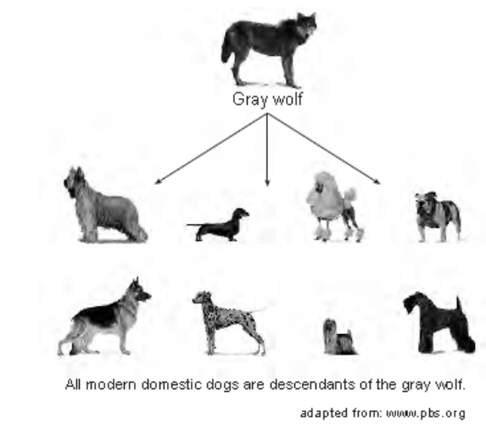

The great variety of modern dogs can best be explained by

(1) selective breeding of dogs over many years (3) genetic alterations in gray wolves alive today

(2) the cloning of domestic dogs (4) natural selection favoring wolves over dogs

18. The diagram below represents the same field of mice hunted by a hawk over a period of three months.



The overall changes in the population of mice can be explained best by

(1) natural selection (3) reproduction

(2) succession (4) mouse extinction

The segments represent the same region of DNA that codes for a particular pigment (color) in these species.

Plant Species A: A C C G C A G G G A T T C G C

Plant Species B: A C C G G A G C G A T T C G C

19. A restriction enzyme is used to cut the DNA from species *A* and *B.* The enzyme binds to the sequence G G G A T T and cuts between G and A*.* State how many cuts will be made in the DNA sequences of each species when this enzyme is used. [1]

Plant species *A* cuts: ____________ Plant species *B* cuts: ____________

20. The diagram below represents one possible evolutionary change that could have led lobe-finned fish to develop into the first amphibians. Amphibians are animals that live on land some of their life.



This change from fins on the lobe-finned fish to legs and feet on the early amphibian is most likely due to

(1) a sudden mutation that changed the gills of the lobe-finned fish to lungs

(2) increased competition between animals that had adapted to living on the land

(3) the need to move to land because of increased competition for food in the ocean

(4) variations among offspring, followed by natural selection

Base your answers to questions 21 and 22 on the diagram below and on your knowledge of biology.



21. Several of the Galapagos Islands are inhabited by grasshoppers, beetles, flies, bees, and butterflies. Finches that feed on these consumers would have beaks adapted for

(1) probing, only (3) crushing or probing

(2) probing or grasping (4) parrotlike feeding or grasping

22. Farmers on a few of the Galapagos Islands have orchards of oranges, apples, grapes, and pears. Which species of finch would consume these foods?

(1) woodpecker finch (3) sharp-beaked ground finch

(2) small ground finch (4) vegetarian tree finch

Base your answers to questions 23 and 24 on the information and chart below and on your knowledge of biology.

The Galapagos Islands are home to many different species of finches. Three finch species, their relative beak sizes, and their food preferences are represented below. All three species live on the same island



23. Which statement is correct concerning the nutritional preferences of these finches?

(1) The three species do not compete for food because they eat different types of foods.

(2) The vegetarian and cactus finches compete for food because they both feed on producers.

(3) The vegetarian and warbler finches compete for food because they both live in trees.

(4) The three species of finches compete for food because their beaks are similar in shape and size.

24. Which process allows for the evolution of finches over time?

(1) natural selection (3) asexual reproduction

(2) selective breeding (4) ecological succession

.

Name _______________________________

Test 9

1. ______  
2. ______

3. ______

4. ______

5. ______

6. ______

7. ______

8. ______

9. ______

10. _____

11. _____

12. _____

13. ________________________________________________________

14. Individuals: ___________________ and ___________________

________________________________________________________________________________

________________________________________________________________________________

15. _____

16. Species _____________

_________________________________________________________________________________

17. ______

18. ______

19. Plant species *A* cuts: ____________ Plant species *B* cuts: ____________

20. ______

21. ______

22. ______

23. ______

24. ______