Dr. Louis A. Cerulli
STUDENT/PARENT HANDBOOK 2019-2020
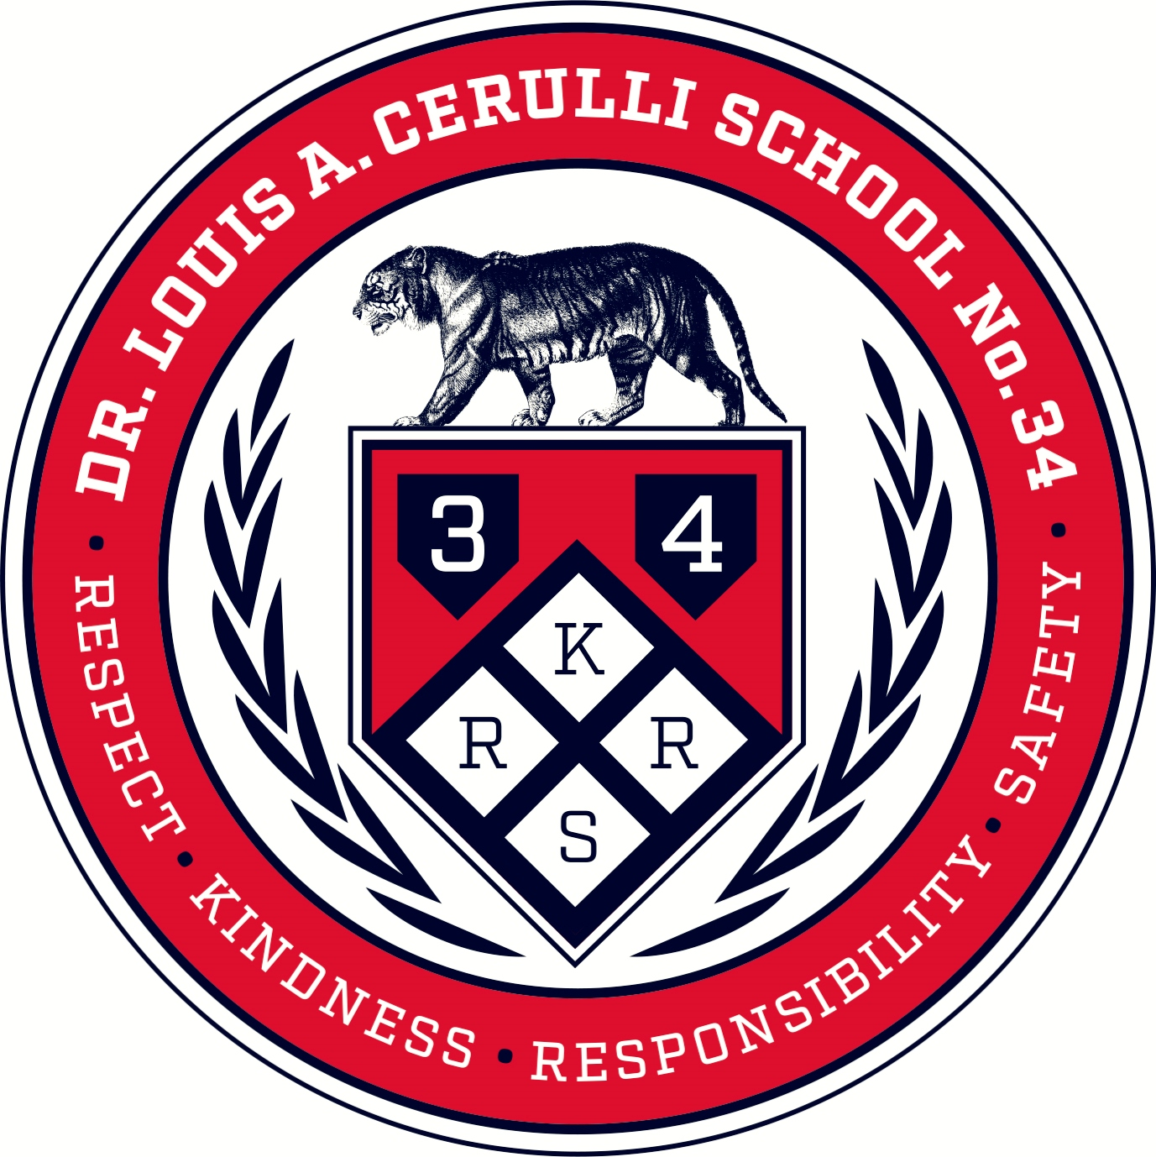

Dave Passero
PRINCIPAL
Email: david.passero@rcsdk12.org

Dianne Agostinelli
ASSISTANT PRINCIPAL
Email: dianne.agostinelli@rcsdk12.org

530 Lexington Avenue
Rochester, N.Y. 14613
Telephone: (585) 458-3210
Fax: (585) 277-0106?
Web Site: www. rcsdk12.org/34

EMERGENCY PROCEDURES
In the event of a natural or man-made emergency during the school day, students will be notified by P.A. announcements or alarms. If time allows, students will be dismissed from school to return to their homes. There are also procedures for keeping students in the building when conditions for dismissal are considered unsafe. Parents wishing to pick up students during such an emergency are asked to go to the Main Office where sign-out procedures will be followed.
In the event school is closed due to snow or other unusual circumstances, announcements will be made on Rochester radio and television stations. Those informed are AM: WBBF, WARM, WHAM, WCGR; TV: Ch. 8, 10, 13, 9; FM: WXXI, WBEE, WISH, WCMF, WPXY, WKLX, WVOR, WARM, WLKA, WDKX, WMAX, WCITY. Other vehicles of information to include Pittsford District Web Site or Enews.
MISSION STATEMENT
We will create a community of independent thinkers who are empowered to attain success academically, artistically, and socially. In partnership with parents and the community, we will deliver content and targeted skill instruction that supports the unique needs of every learner.
VISION STATEMENT
Your Future Begins Here Empowered to Learn, Interact & Succeed
.
DISCIPLINARY ACTION
Violation by Students - A student who shall have been found in violation of Board of Education policy shall be subject to such disciplinary action as may be appropriate including suspension not to exceed five (5) days, probation, loss of privileges, reprimand or warning, or such other legally-authorized disciplinary measure as shall be deemed appropriate under the circumstances. It is the policy of the Board of Education that disciplinary problems be handled promptly and appropriately by the School District representatives most directly concerned, and that Building Principals and the Superintendent be involved in only more serious disciplinary problems. Please visit www.rcsdk12.org for district policy and the code of conduct.

ATTENDANCE/Pick Up PROCEDURES
Student attendance to school is crucial to successful learning. Please make every effort to make sure your child arrives on time to school. In the event of an absence please:
- Call the office and let them know your child will not be in school. A parent or guardian of any student not reported absent will receive a phone call to verify the student’s absence.
- All students tardy to school, dismissed early, or returning from an appointment, must have their parent sign them in or out of school in the main office.
- A note from a parent or guardian stating the reason for an absence most be turned in to the office or homeroom upon return to school.
- Chronic tardiness/absences will lead to interventions from the school, district and county agencies.
Arrival and Dismissal

- Students being delivered or walking to school must arrive at 9:00 am. We do not have coverage to monitor students prior to 9:00 am. At 9:00 am, students will enter the building and go to the classroom for breakfast. T

- If your child must be picked up earlier than the regular dismissal time please send a note to his/her teacher. This note will be sent to the office. In your note, include the name of the person who will be picking up your child, especially if that person is not authorized to on your emergency form. If you call in to change the dismissal plans for your child, please let us know before 2:30 p.m. All students dismissed early must be signed out and picked up in the office. Do not go to your child’s classroom.

End of the day dismissal procedures are as follows:

If you are picking up your child by car or by walking at the end of the day, please follow these procedures:

- All students will exit through the front entrances of the school.
- Please wait for the students in the main entrance.
- No Parking on Lark Street. Lark Street is reserved for school busses only.

Change of Student Info
Change of Address Policy – We will require proof of your new address. We will NO longer be taking these changes over the phone. Here is what is acceptable for proof:

- RENT, LEASE OR MORTGAGE RECEIPTS
- CORRESPONDENCE FROM DSS
- PROPERLY ADDRESSED PAYROLL CHECK STUBS (no more than 30 days old)
- SIGNED AFFIDAVITS
- UTILITY BILL (ie: Telephone, RG&E, Water Bill, or Cable NO CELL PHONE BILLS and no more than 30 days old)
All changes of student information–address, phone number, parent name or guardianship–should be reported to the main office immediately. NO ADDRESS CHANGES WILL BE PROCESSED OR TRANSPORTATION ISSUED WITHOUT PROPER VERIFICATION SUCH AS RENT RECEIPT, UTILITY BILL, NYS DRIVER’S LICENSE, ETC. Changes in guardianship must be verified by documentation from Family Court, Department of Social Services or guardianship papers notarized by a CSD official. Administrative offices will be provided “change of student information” forms to be sent to parents and returned to the house office with changes noted and proper verification. (See “change of student information form” in the back of the Handbook)

Classroom Interuption Policy

Visitors
For the safety of all our children, all visitors must enter by the front door to obtain a visitor’s badge before going into the school. Please sign in and out of the school. If you are dropping an item off to your child, you will need to leave it at the office for someone to bring to your child. Staff members are instructed to stop and question any adult without a visitor’s badge or Staff Identification Card. They are also instructed to stop and question any adult exhibiting questionable behavior. If you wish to speak with a teacher, we request that you call first to set up an appointment. If you would like to visit a classroom for any period of time please schedule the time with the teacher at least 24 hours in advance. No visitors will be allowed to visit classrooms unless it has been scheduled with the classroom teacher. The purpose is to limit the number of interruptions to instruction within the school day. The teachers’ day begins at 7:15AM and ends at 2:30PM for grades K-3. Teachers in grades 4-6 begin at 8:30AM and end at 3:30PM. Your understanding of their schedule is greatly appreciated.
DRESS CODE
The State of New York has passed new S.A.V.E. legislation (Safe Schools Against Violence in Education Act), which insists that each public school district in New York State adopt a code of conduct policy, which includes a student dress code.
Under this new legislation “all students are expected to give proper attention to personal cleanliness and to dress appropriately for school and school functions.” A student’s dress, grooming and appearance, including hair style/color, jewelry, make–up and nails, shall:
• Be safe, appropriate and not disrupt or interfere with the educational process.
• Recognize that brief garments such as, short shorts, short skirts, short skirts, tube tops, net tops, halter tops, spaghetti straps, short baring back or waist tops, plunging necklines and see through garments are not appropriate.
• Underwear must be completely covered with outer clothing.
• Include footwear at all times.
• Shorts and skirt length must meet the following criteria – Standing upright with arms against the side, arms straight down towards feet, and fingers extended towards the feet, the shorts or skirt must (at least) reach the tip of the longest finger.
• Not include items that are vulgar, obscene, libelous or denigrate others on account of race, color, religion, creed, national origin, gender, sexual orientation or disability or promote alcohol or drug use.
Students who violate the student dress code shall be required to modify their appearance by covering or removing the offending item. Please discuss these state guidelines with your adolescent. Thank you for your understanding and support.
CARE OF PERSONAL PROPERTY
A student’s personal property is the sole responsibility of the student. Students should not bring large sums of money or valuable irreplaceable personal items to school. Under no conditions should money or valuables be left lying around loose. Students must report any theft to their Assistant Principal and complete a theft report. All valuables, including calculators, wallets and electronic equipment must be locked in gym lockers during gym class and not left in personal backpacks.

The replacement of lost or stolen property is not covered by the District’s insurance and the District does not replace personal property.
HOMEWORK
Homework is an important part of school. It is designed to be the independent practice of skills taught during classes. In most courses, homework performance will be included in the determination of grades.
PASSES
Students are required to have a pass to excuse tardiness to class, to provide permission to go to the library, and to grant permission to be in the halls during a class. Pass privileges may be withheld as a behavioral consequence to a disciplinary or academic incident.
A/B/C/D Day
A number of classes meet on different letter days during the year. Art, physical education, general music, band, music and library all examples of courses that meet on different letter days. These courses will meet on either A Day, B Day, C Day, D Day. Check with your child’s teacher for your son’s/daughter’s schedule.

REPORT CARD AND GRADING INFORMATION
All grades are based on a combination of tests, quizzes, projects, reports, participation and effort. Rochester City School District uses a numeric grade to communicate progress in grade K-5 and letter grades for grade 6. The number grade represents a category of performance. Student’s individual progress is also reported in comment section. These comments will be on the report card that is sent home. Report Cards for grades K-5 will come home with students and should be expected home around the dates below. 6th Grade report cards are mailed home.

- 1st Quarter Report Cards – Week of November 18th
- 2nd Quarter Report Cards – Week of February 10th
- 3rd Quarter Report Cards – Week of April 27th
- 4th Quarter Report Cards – Last day of school for students (K-6)

REPORT CARD CONVERSION TABLE
K-5 Teachers will use a 9 point scale to provide parents with a better sense of student progress. Below is the breakdown of the 9 point scale:

Exceeds Standards | 9: Exceeding standards with distinction  8: Exceeding standards
Meets Standards | 7: Beginning to exceed standards  6: Meeting the standards
Partially Meets Standards | 5: Meeting most of the standards  4: Partially meeting standards  3: Beginning to meet standards
Far Below Standards | 2: Far Below standards  1: No evidence of meeting standards

Effort and responsibility of learning will be reported as follows:

Effort and Responsibility
O | Outstanding
G | Good
S | Satisfactory
I | Improving
N | Needs Improving

6th grade students will receive report cards that are similar to the 7th-12th grade. The report card will provide letter grades, absences, and comments. An example is below:
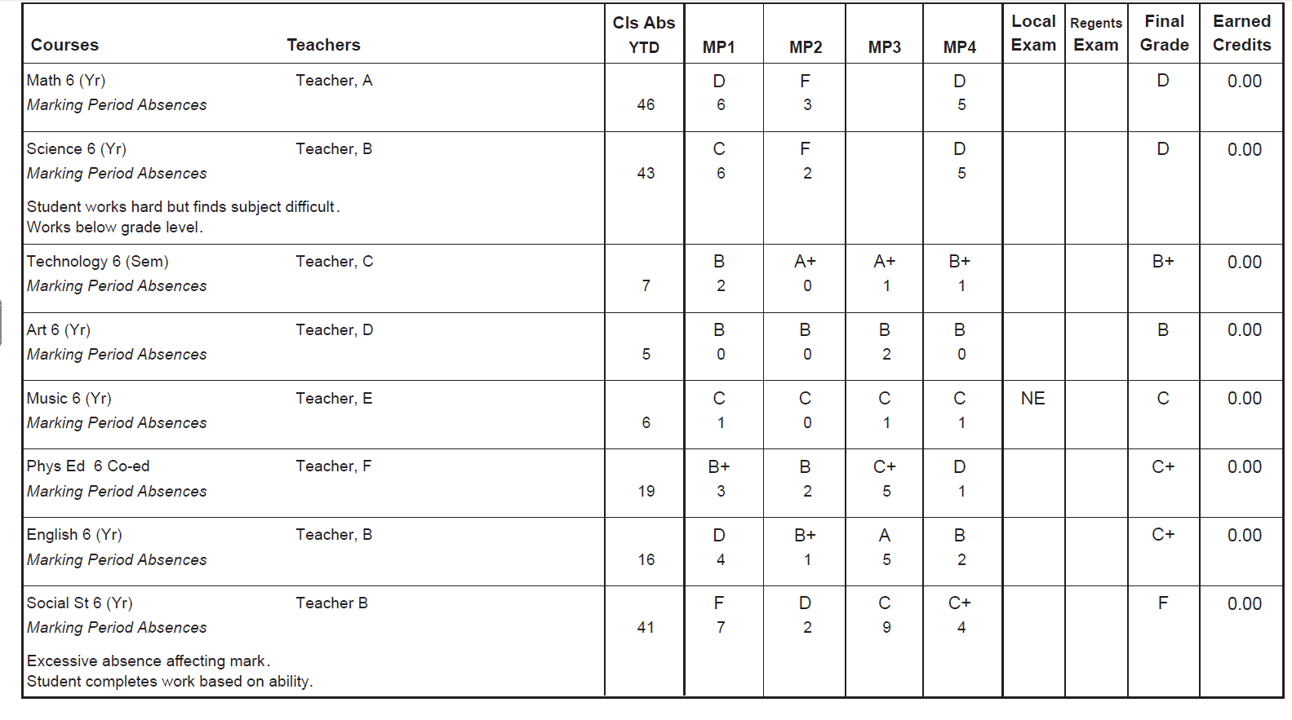

Social Emotional Support
Social Worker
Ann Miraglia (Ann.Miraglia@rcsdk12.org) 458-3210 ext. 1123 (Suite 112C)
- Provide counseling to our Special Education Students who have counseling services on their Individual Education Plans (IEP).
- Provide General Education students with ERSS counseling services for such things as: anger management, social skill building, grief counseling, anxiety,
- Talk with teachers and students that are in crisis and need temporary support.
- Facilitate mediations between students.
- Facilitate suicide assessments.
- Coordinate efforts between school, community agencies and parents.
- Work with families that are considered homeless under the McKinney Vinto Act.
- Supervisor for Primary Project.
- Coordinate efforts and do home visits for various reasons. Ie. Attendance, signatures for paperwork, contact information for parents, etc.
- Facilitate CPS referrals for various reasons for students.
- Handle psycho-socials for mandated students and students that are being referred to the committee on Special education.
- Hand out and refer families to community resources.
- Coordinate with parents about their child and what the child is in need of at a certain time.
- Facilitate efforts when mobile crisis is necessary for a student.
- Sit on the ESS and RTI teams to help coordinate services for students.

Center for Youth - Prevention Coordinator
- Social/emotional support for students in times of crisis
- Restorative Justice
- Provide small group counseling.
- Outreach counseling for parents and families.
- Conduct staff and peer lead peer mediations.
- Assist with the school’s ATS (Alternative to Suspension) room by providing post suspension follow-ups with students to ease transition to the classroom.
- Assist administration during transitions, lunchroom monitoring, arrival and dismissal.
- Record and provide electronic data regarding monthly services provided to student population.

Alternate to Suspension
Services:
- Socio/emotional support for students in times of crisis
- Develop and instruct learning workshops based on student interest and need as they enter the Alternative to Suspension Room (ATS):
- Anger management, self-esteem, communication, mental/physical well-being and hygiene and many more relevant student based workshops.
- Preventative education to students and families.
- Informal interventions as need arises throughout the school
- Act as mediator for students and teachers
- Classroom support for individual students returning to class and continued monitoring for those who need additional support
- Provide remediation and instructional support to students assigned to the ATS room
- Contact parents as needed
- Implement school policy of written assignments for students entering the ATS room
- Assist in transitioning students at dismissal
- Electronically track students attendance in the ATS room
- Monitor student movement throughout the hallways to ensure a smooth transition

School Psychologist
Dr. Jennifer Picoolo (Jennifer.piccolo@rcsdk12.org) 458-3210 ext. 1125 (Suite 112E)
The School Psychologist provides direct support and intervention to students, consults with teachers, families, and other school-employed mental health professionals (ie. school counselors, school social workers) to improve support strategies, works with school administrators to improve school-wide practices and policies, and collaborates with community providers to coordinate needed services.
Services:
- Response to Intervention (RTI) Coordinator.
- Cognitive and Academic Assessment for Committee on Special Education (CSE).
- Coordinate Functional Behavioral Assessments (FBA) and Behavior Intervention Plan (BIP).
- Section 504 Coordinator
- CSE Point of contact for the school’s Coordinating Administrator of Special Education (CASE)
- Progress monitoring for at-risk students.
- Consultation and collaboration with the school community and outside mental health agencies.
- Facilitate Peace Circles and Classroom Community Building.
- Consult with School Social Worker and School Support Staff.
- Individualized Education Program (IEP) Development.
- Support families in finding mental health providers and connecting them to community agencies.
- Crisis Intervention and Grief Counseling.

Speech-Language Pathologist

Molly Rountree (Molly.Rountree@rcsdk12.org) 458-3210 ext. 1124 (Suite 112D)
Elizabeth Davis (Elizabeth.Davis@rcsdk12.org) 458-3210 ext. 1121 (Suite 112A)
Services:
- Provide direct speech-language intervention services.
- Complete speech-language assessments and/or evaluations.
- Hearing services- liaison with Audiology Department.
- Completion of evaluation reports and referrals.
- Parent communication/conferences.
- Collaboration with teachers and staff.
- Classroom observations.
- Medicaid data entry.
- Participation in building-level intervention services.
- Participation in school-wide behavior support services.

