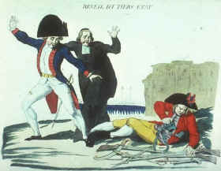
The French Revolution
Inspired by the success of the American Revolution, French citizens overthrew the noble, ruling class and establish a democratic government. The French monarchy under Louis XVI was viewed as oppressive and corrupt and the social structure was rigid, meaning it did not allow for social mobility. The poor, uneducated class, known as the Third Estate, made up 98% of the population. The upper classes of nobility and clergy (the First and Second Estates, respectively) only made up a mere 2% of the entire population, as represented in the cartoon. It is no wonder the people of France rose up in a spirit of nationalism to overthrow the oppressive system and establish a society controlled by themselves. They wanted to govern themselves as a democracy but maintain their French identity. This is the essence of nationalistic movements.
The course of the French Revolution is very complicated. Control of the Revolution passed from the moderate bourgeoisie

