UNIT II
How Revolutionary Was the American Revolution?

STUDENT GUIDE SHEET
Directions: The word revolution means change. We know that the Revolutionary War brought some change to America - but just what kind, and how much? These are the questions raised by this DBQ.

There are several steps to forming an educated opinion.
1. Read the Background Essay. It provides a context for answering the question.
2. Skim through the 17 documents to see what they are about. Many are short.
3. Read the documents slowly. For each, use the margin space or a Document Analysis Sheet to record:
a. Who or what is the source? Is it a primary or secondary source? b. What is the main idea of the document?
4. Redefine the analytical question in your own terms. What precisely are you looking for in these documents?
5. Organize the documents into analytical categories. Classic categories in historical analysis are politics, economics, and social groups. You may discover subcategories within these large categories. Where, for example, would you place land reform? the status of women?
6. Make judgments on the amount of change in each category or subcategory.

The Documents:
Document A: La Destruction de la Statue Royale | Document J: Slave Trade
Document B: "We hold these truths ..." | Document K: Abolition
Document C: Devereux Jarratt | Document L: Valedictorian of a New York Free School
Document D: Billiards in Hanover-Town | Document M: Abigail Adams
Document E: A New York Tory Estate | Document N: 19th Amendment
Document F: Patriot Manors | Document O: Divorce Petitions
Document G: Primogeniture | Document P: Northwest Ordinance
Document H: Charles Beard | Document Q: Letter from Three Seneca Leaders
Document I: Six Legislatures

How Revolutionary Was the American Revolution?
The broad outline of the Revolutionary War is familiar to most of us. The American Revolution, also called the War for Independence, took place between 1775 and 1783. It was a fight waged by 13 British colonies against their mother country, England. At the time, England was the most powerful country in the world. The war, rather surprisingly, was won by the colonies who named themselves the United States of America. With the signing of the Versailles Peace Treaty in 1783, the United States gained what it had been fighting for, its independence.

More than two centuries later, the American Revolution has left its clear mark on this land. The Philadelphia 76ers; The New England Patriots; Washington, DC; Madison, Wisconsin; The 4th of July; Sam Adams beer; Crispus Attucks High School in Indianapolis; Pulaski Day; The TV show "The Jeffersons," - hundreds, even thousands of American teams, towns, counties, streets, schools, and families can trace their names to the same remarkable event, the American Revolution.

Beyond names, the Revolution has left other footprints on our historical landscape - the Stamp Act, the Boston Massacre, the Boston Tea Party, the Declaration of Independence, the battles of Lexington and Concord, Saratoga and Yorktown. Certain stories from the Revolution have etched themselves on America's soul -Washington's men walking barefoot through the snow to Valley Forge, 16-year-old boys facing Redcoat musket balls at 40 paces, black slaves torn by the decision to support the American cause of national freedom or fight for the British and the hope of personal freedom.

Amidst all this history and all these national memories, is it fair to ask just how much of a revolution was it? Did the Revolution really produce significant long-lasting changes? A high school student in the 1950s never even thought about the question. It was assumed that the Revolution meant big changes, like democracy and liberty and equality for all. Then in the 1960s and 1970s, history books and high school students did a flip-flop. It was the time of Vietnam and civil rights protest and all American history was suspect. Many saw the Revolution as phony freedom.

Historians have also had conflicting views on the question. One group has argued that the Revolution was not very revolutionary. These historians see the Revolution as conservative; that is, even while throwing off British rule, the American leaders tried to conserve or hold onto many of the old ways. These historians admit we got our political independence from England but there was no significant social or economic revolution. There was no class war where the poor destroyed the rich. In fact, what really happened, they argue, is that one group of rich white male American leaders, like Washington and Jefferson, took over from another group of rich white male leaders - King George and the members of British Parliament. Two famous historians in this h'ttie-or-no-change group were Mary and Charles Beard. They studied the U.S. Constitution, which was written just four years after the Revolutionary War ended, and argued that it was drafted by wealthy white males many of them lawyers - for the purpose of hanging onto their power and wealth.
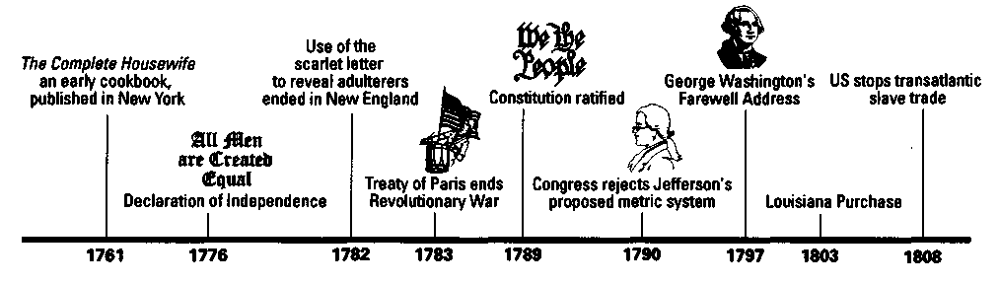
This idea of a conserving revolution that produced limited change has been supported more recently by historians like Edmund Morgan and Howard Zinn. Morgan believes that the Revolution was largely an intellectual movement, that it marked a victory for the idea of equality but that further changes were largely accidental. Zinn also believes the Revolution was quite limited in scope. In 1980 he wrote: "It seems like the rebellion against British rule allowed a certain group of the colonial elite to replace those loyal to England, give some benefits to small landholders, and leave poor white working people and tenant farmers in very much their old situation." In other words, not much change.

A second group of historians views the American Revolution differently. They see the Revolution as more radical, producing some significant changes above and beyond independence. An early leader in this group was J. Franklin Jameson. Way back in 1926 Jameson argued that the American Revolution was much more than a political break from England; it also sparked a social change that lives with us still. A more recent historian in this group is Alfred E. Young. Young draws a distinction between what he calls the external revolution and the internal revolution. The external revolution was the break from England. The internal revolution resulted from the changes that took place within the United States as a result of the war. While admitting to limits, Young argues that an internal revolution did occur.
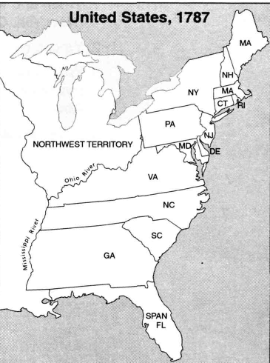
In 1992 historian Gordon Wood added even more fuel to the debate. In his book The Radicalism of the American Revolution, Wood wrote: "By the early years of the nineteenth century the Revolution had created a society fundamentally different from the colonial society of the eighteenth century. It was in fact a new society unlike any that had ever existed anywhere in the world." Wood calls the American Revolution the most change-producing, radical event in American history.

Wood won the Pulitzer prize for this work, but he also took a lot of heat. One concern was that Wood did not have enough to say about women, blacks, and Indians.

Before you move on to examine some documents, a caution is needed. When historians of any stripe have tried to calculate the degree of change caused by the Revolution, they have run into at least two problems. Problem #1 is the problem of adequate data. In order to measure change caused by the Revolution, you have to know what existed before and what existed after. The data is often missing or is very thin.
Problem #2 is the problem of proving cause and effect. Just because one thing occurs after something else does not mean it was caused by the first event. Also, some of the results of the Revolution may not have occurred immediately. Should the Revolutionary War, which ended in 1783, get credit for ending the Atlantic slave trade in 1808? Should the Revolution in any way get credit for winning women the right to vote in 1920? In other words, is there a time limit on causation?

Amidst all of this disagreement, one thing seems clear: the debate over the American Revolution of 1776 carries into the 21st century. Examine the 17 documents that follow and join the ongoing discussion: How revolutionary was the American Revolution ?

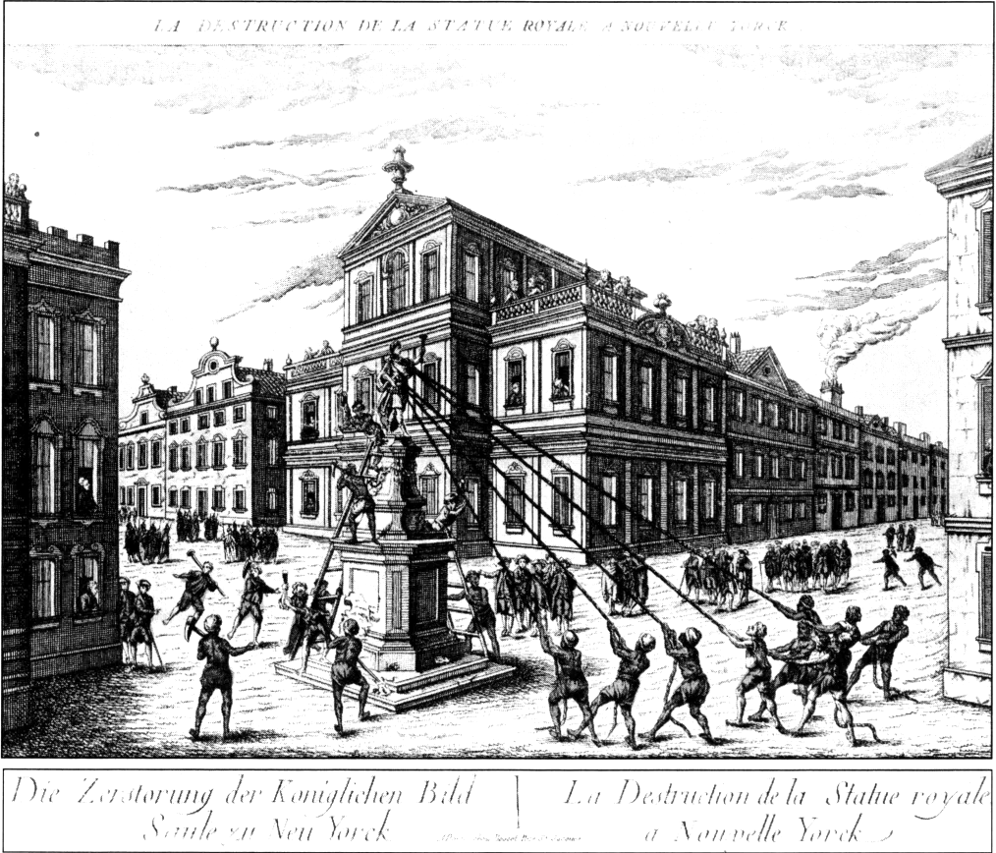
Document A

Source: La Destruction de la Statue Royale a Nouvelle Yorck. Reprinted by permission of Library of Congress. Print by Andre Bassett, 1770s, LC-USZ62-22023.

Document B
We hold these, truths to be self-evident: that all men are created equal; that they are endowed by their creator with certain inalienable rights; that among these are life, liberty, and the-pursuit of happiness; that to secure these rights, governments are instituted among men deriving their just powers from the consent of the governed....
Source: The Unanimous Declaration of the Thirteen United States of America. Congress, July 4, 1776.

Document C
In our high republican times there is more leveling than ought to be, consistent with good government.... At present there is too little regard and reverence paid to.. .persons in public office.... An idea is held out to us that our present government and state are far superior to the former, when we were under the royal administration; but my age enables me to know that the people are not now by half so peacefully and quietly governed as formerly;... I know the superiority of the present government. In theory it is certainly superior; but in practice it is not so. This can arise from.. .want of a proper distinction between the various orders of people.
Source: Reverend Devereux Jarratt, 1794. Quoted in J. Franklin Jameson, The American Revolution Considered as a Social Movement, 1926.

Document D
Source: Drawing by Benjamin Henry Latrobe, November, 1797. Maryland Historical Society, Baltimore, Maryland.
Billiards in Hanover-Town (Virginia)
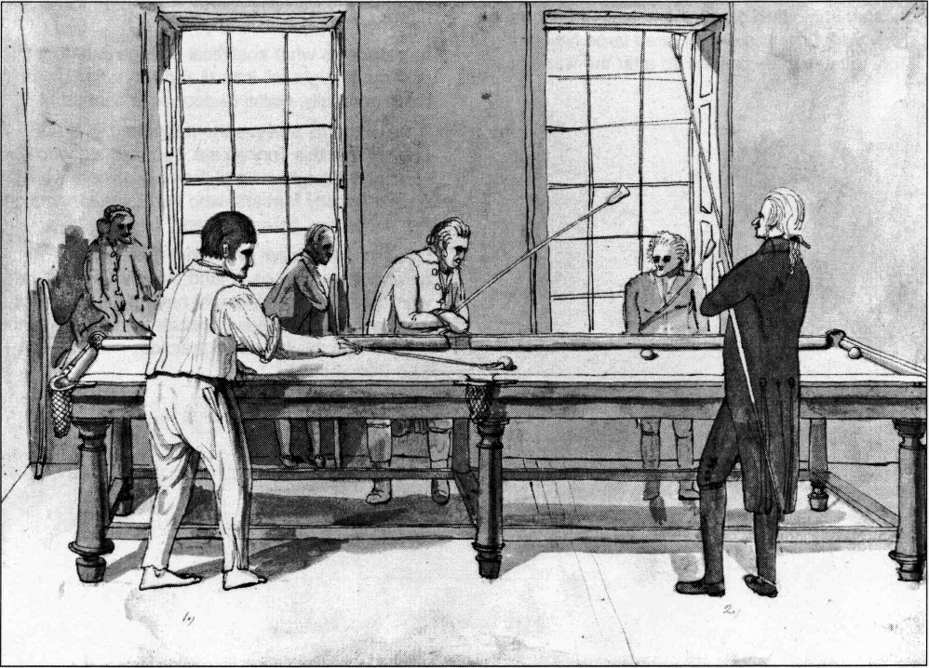

Document E
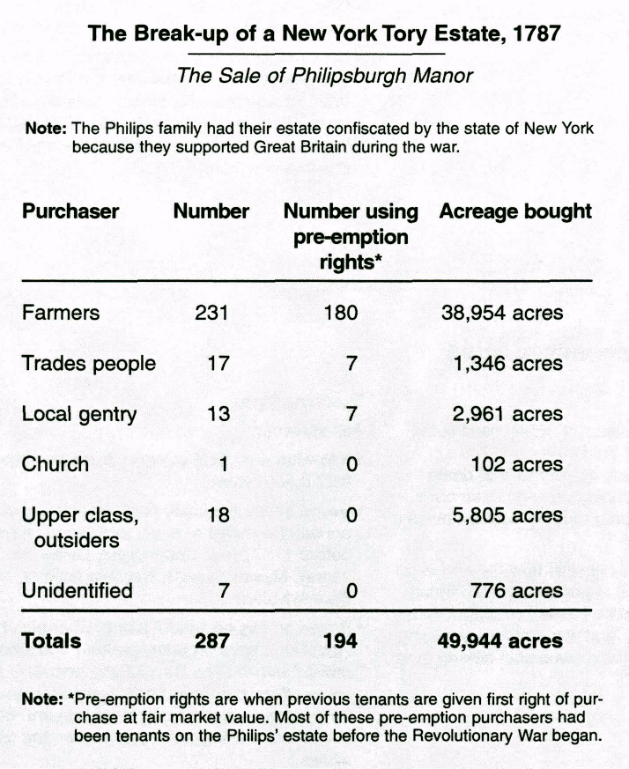
Source: Beatrice G. Reubens, "Pre-Emptive Rights in the Disposition of a Confiscated Estate, Philipsburgh Manor, New York," William and Mary Quarterly, Vol. 22, 1965. Reprinted by permission of William and Mary Quarterly.

Document F
If one had any lingering doubts about the benefits of pre-emption to Philipsburgh's tenants and to New York as a whole, he would have only to contrast the history of New York's patriot manors after the Revolution. Maintaining their estates in tact, the descendants of the Livingstons and Van Renssalaers and others prolonged...leasehold tenures affecting 260,000 persons and 1,800,000 acres as late as 1846.
.. .It might (be interesting to wonder what would have happened) if the patriot manor lords had been Tories and their tenants had gained the pre-emption right during the Revolution.
Source: Beatrice G. Reubens, "Pre-Emptive Rights in the Disposition of a Confiscated Estate: Philipsburgh Manor, New York." William and Mary Quarterly, Vol. 22, 1965. Reprinted by permission of William and Mary Quarterly.

Document G
Last Seven States to Abolish Primogeniture*
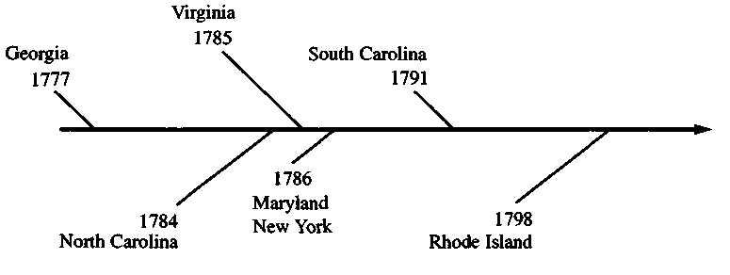
Source: Harry M. Ward, The American Revolution, 1995.
* Primogeniture means that when the father and owner of an estate dies, the landed property goes to the first-born son. This was done to keep family estates in one piece and keep the family powerful.

Document H
A survey of the economic interests of the (55) members of the (1787 Constitutional) Convention presents certain conclusions:
• A majority of the members were lawyers by profession.
• Most of the members came from towns, on or near the coast,.. .regions in which personalty* was largely concentrated.
• Not one member represented in his...economic interests the small farming or mechanic (working) classes.
• The overwhelming majority of members, at least five-sixths, were...to a greater or less extent economic beneficiaries from the adoption of the Constitution....
• Personalty invested in lands for speculation was represented by at least fourteen members....
• Personalty in the form of money loaned at interest was represented by at least twenty-four members....
• Personalty in mercantile (trade), manufacturing, and shipping lines was represented by at least eleven members....
• Personalty in slaves was represented by at least fifteen members....
It cannot be said, therefore, that the members of the Convention were "disinterested." ...(A)s practical men they were able to build the new government upon the only foundations which could be stable: fundamental economic interests.
* Note: Personalty is any personal property other than land.
Source: Charles A. Beard, An Economic Interpretation of the Constitution of the United States, 1913.

Document I
Economic Status of the Representatives in Six Colonial/State
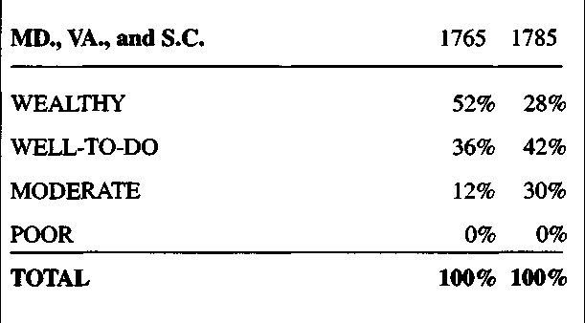
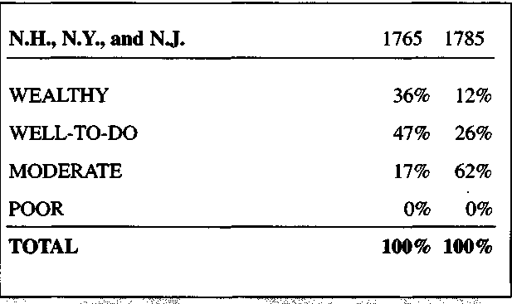
Legislatures
KEY: Wealthy....................over £5000
Well-to-do........£2000 - £5000
Moderate............£500 - £2000
Poor........................£0 - £500
£ = British Pound
Source: Adapted from Jackson Turner Main, "Government by the People: The American Revolution and the Democratization of the Legislatures." William and Mary Quarterly, Vol. 23, 1966. Reprinted by permission of William and Mary Quarterly.
Document J
The migration of such persons (staves) as any of the states now existing shall think proper to admit shall not be prohibited by the Congress prior to the year 1808;....
Source: United States Constitution: Article 1, Section 9, Clause 1.
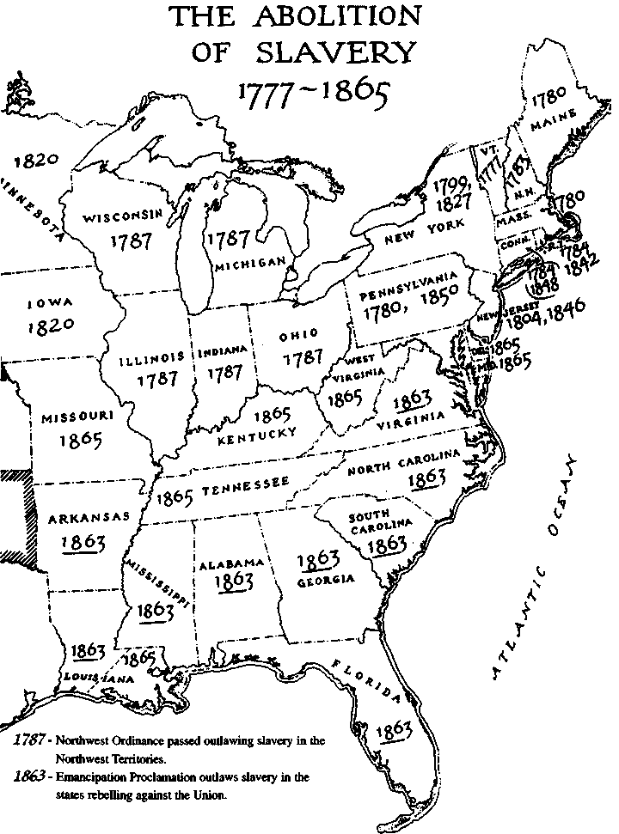
Document K

Note: The states displaying two dates all passed gradual abolition acts. The first date represents the year gradual abolition acts were passed. The second date indicates when the last slave died or was freed.
Source: Data from varied sources including Leon F. Litwack, North of Slavery, 1961.

Document L
Speech made by a young African-American in 1819, valedictorian of his New York free school
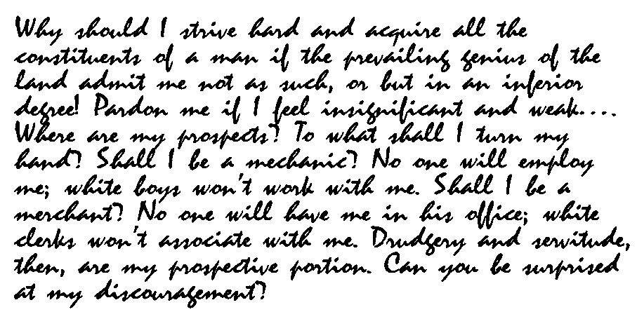
Source: Andrews, History of the New York African Free-Schools. As reprinted in Leon Litwack, North of Slavery, 1961.

Document M
...in the new code of laws which I suppose it will be necessary for you to make I desire you Remember the ladies, and be more generous and favourable to them than your ancestors. Do not put such unlimited power into the hands of the Husbands. Remember all Men would be tyrants if they could. If particular care and attention is not paid to the ladies we are determined to foment a Rebellion, and will not hold ourselves bound by any Laws in which we have no voice or Representation.
Source: Abigail Adams' letter to her husband John Adams, March 31, 1776. The Book of Abigail and John: Selected Letters of the Adams Family, 1762-1784. Reprinted by permission of the publisher from The Adams Family Correspondence, Volume I, edited by L.A. Butterfield, Cambridge, Massachusetts: Harvard University Press, Copyright (c) 1963 by the Massachusetts Historical Society.

Document N
The right of citizens of the United States to vote shall not be denied or abridged by the United States or by any state on account of sex.
Source: United States Constitution, Amendment 19 (1920).

Document O
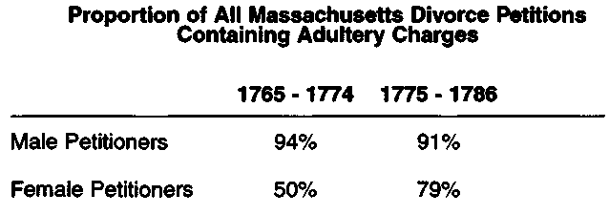

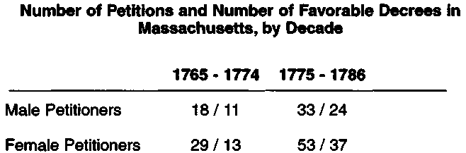
Source: Nancy F. Cott, "Divorce and the Changing Status of Women in Eighteenth Century Massachusetts," William and Mary Quarterly, October 1976.
Reprinted by permission of William and Mary Quarterly.

Document P
"Utmost Good Faith" Clause from the Northwest Ordinance, 1787
The utmost good faith shall always be observed towards the Indians; their land and property shall never be taken from them without their consent; and, in their property, rights, and liberty, they shall never be invaded or disturbed, unless in just and lawful wars authorized by Congress, but laws founded in justice and humanity, shall from time to time be made for preventing wrongs being done to them, and for preserving peace and friendship with them.
Source: Northwest Ordinance, 1787.

Document Q
Letter from three Seneca Indian leaders - Big Tree, Cornplanter, and Half-Town - to President of the United States, George Washington, 1790
When your army entered the country of the Six (Iroquois) Nations, we called you the town destroyer; to this day, when your name is heard, our women look behind them and turn pale, and our children cling to the necks of their mothers....
You told us you could crush us to nothing; and you demanded from us a great country, as the price of that peace which you had offered to us: as if our want of strength had destroyed our rights. Our chiefs had felt your power, and we were unable to contend against you, and they therefore gave up that country. What they agreed to has bound our nation, but your anger against us must by this time be cooled, and although our strength is not increased, nor your power become less, we ask you to consider calmly - Were the terms dictated to us by your commissioners reasonable and just?...
All the land we have been speaking of belonged to the Six Nations. No part of it ever belonged to the king of England, and he could not give it to you.
Note: The Seneca, along with the other Iroquois nations, fought on the British side during the Revolution.
Source: Great Documents in American Indian History. Wayne Maquin and Charles Van Doren, editors, 1973.

