**Quick Reference: Assistive Technology for Students with an IEP**

**M**edical Management and **A**ssistive **T**echnology for **Ch**ildren

[MATCHTeam@rcsdk12.org](mailto:MATCHTeam@rcsdk12.org)

**REFERRALS**

When considering a referral to the Assistive Technology team:

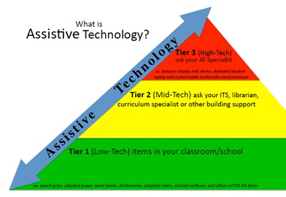

Tier 3 includes laptop, word processor, tablet, augmentative communication device—high tech equipment. It also MAY include service recommendation.

Tier 2 supports could be book on CD, school owned Chromebooks/tablets, pencil grips, special paper, visual schedules.

Tier 1 supports should be tried PRIOR to referral and results documented on the referral form.

**CSE MEETINGS**

* Assistive Technology should be considered at all meetings (per IDEA)-no referral is necessary to consider Tier 1-2 supports.
* If building team has tried Tier 1-2 supports and HAS DOCUMENTATION that there is a difference in quality/quantity of work with the use of school equipment, please follow guidelines for adding equipment.
* EXISTING assistive technology on the IEP should be reviewed! Please use the ***Assistive Technology Device Review*** form to note whether a device will be continued or discontinued. NOTE IN SUMMARY IF REMOVED! Forward a copy to MATCH email.

**When adding equipment/assistive technology to the IEP**

* Use GENERIC terms (e.g. word processor). DO NOT list specific equipment (e.g. Chromebook, iPad). See list of generic terms in current use.
* List equipment under *ASSISTIVE TECHNOLOGY DEVICES*.
* RCSD policy: laptops, computers, word processors, tablets (high tech devices) MUST have a MATCH recommendation to be ***added*** to the IEP. ** “ACCESS to” a device CAN be added without MATCH and indicates THE BUILDING provides/has this access (Tier 1-2).

MATCH provides BUILDING provides

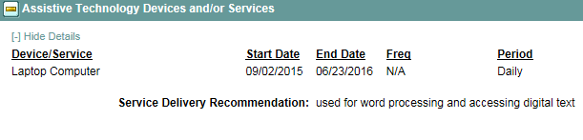 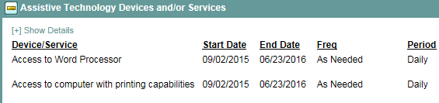

* RCSD policy: AT Service or AT Consultation MUST have a MATCH recommendation to be ***added*** to the IEP. This service should be listed under **Support to Staff on Behalf of the Student**.
* If you get a temp placement with assistive technology equipment or service please NOTIFY MATCH before holding the final meeting.

**Generic Terms for assistive technology currently in use (most frequently used):**

* Word processor
* Communication device
* Picture symbols
* Digital text (note, this is NOT a device, rather the format of the text allowing for audio support)

**if you have a question about how to document assistive technology, PLEASE ask us!