|  |  |
| --- | --- |
| Day | Events |
| Monday 1/19/15 | **NO SCHOOL- Martin Luther King Jr. Day Observed** |
| Tuesday  1/20/15 C | * Mark Davis @ Meeting 8:00-10:00 a.m. * Terri Orden- Registrar Meeting 10:00-12:00 * Mark and Language Coaches visit classrooms 11:00-1:30 (Re: iPads, headphones, etc.) * Professional Development 2:00-3:00  Data Team Meeting (215) * Martin Luther King Assembly/Award for Eh Tee @ SOTA (evening) |
| Wednesday 1/21/15 D | * 8:30 Leadership Meeting (Main Office) * Students projected to leave RIA will meet with Terri and Mary throughout the day * 2:00-3:00 iPad Collegial Circle Meeting (215) |
| Thursday 1/22/15 A | * 8:30 Leadership Meeting (Main Office) * 4th Period Elementary Meeting 232 * Professional Development 2:00-3:00  Teacher Webpages II (221) * Board Meeting @ 6:00 p.m. RIA will receive the “I Believe Award – Yes We Can Award” (Everyone is invited to attend) |
| Friday 1/23/15 B | * 8:30 Leadership Meeting (Main Office) * 4th Period ESOL Meeting (206) |

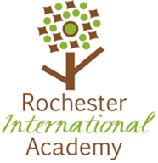

## Upcoming Events

* January 26th-30th MIDTERM WEEK
* January 30th Assemblyman Harry Bronson will be at RIA 12:00-1:00 p.m.
* February 2nd NWEA Testing Window Begins
* February 3rd Data Team Meeting
* February 13th SLOs due for Content Teachers and ESOL push-ins

## Quote of the Week

“Teachers have the potential to be the gatekeepers of students’ futures. When they have high expectations and recognize the potential and uniqueness of each student, they honor not only students’ cultural and linguistic characteristics, but also become partners in their successes.”

-Dr. Carmen P. Sosa

Mission Statement  
The Rochester International Academy is designed to facilitate the cultural and academic transition of newly arrived English Language Learners through rigorous language instruction and interdisciplinary learning in collaboration with families and community.

Vision Statement  
RIA students will learn English to be successful scholars and to have full access to College and/or Career opportunities.

RIA’s Mantra

“Today I am somebody special and soon I will be somebody great by the decisions that I make.”

# This Week’s Events

January 19, 2015

Volume 4, Issue 19

Rochester International Academy POST

All elementary students have been given their midyear ORRs and new instructional groups have been formed. Teachers are in the process of completing students’ midyear profiles. It was exciting to meet as a team to review the growth that students are making. Some students were working on letter formation and sound/symbol relationships and midway through the year they are able to write complete sentences. How exciting!

## Elementary News

## Photo(s) of the Week

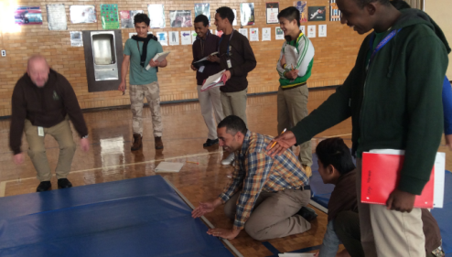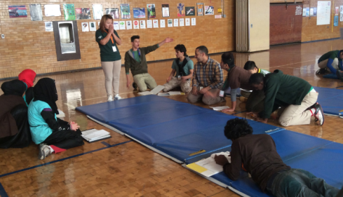

This week’s photo of the week is of Mr. Skinner and Ms. Lucyshyn’s science class.

The pictures are from the 8th period Science class that Corey and Laura teach together. The students had to create a prediction and then a hypothesis for who would jump the farthest. Then, the students had to create their own procedures. All students decided which steps to put into the final procedure. We came back together as a group to jump and to record the data. Finally, the students had to write a conclusion for the experiment. Check out Mr. Davis jumping too!

## Meet RIA’s Newest Students

All students have arrived since 12/1/2014

|  |  |  |  |
| --- | --- | --- | --- |
| Student Name | Home Country | Grade | ESOL/ Classroom Teacher |
| Ayat Al Sallami | Iraq | 7th | Harris |
| Fadak Al Sallami | Iraq | 3rd | Malady |
| Thashu Gurung | Nepal | 8th | Duffy |
| Nadin Kori | Sudan | 9th | Lucyshyn |
| Nadir Kori | Sudan | 2nd | Malady |
| Nadrein Kori | Sudan | 6th | Consagra |
| Nefin Kori | Sudan | 5th | McGorty |
| Destalem Lemlem | Eritrea | 9th | Lucyshyn |
| Aiti Magar | Nepal | 12th | S. Consagra (returning student) |
| Fahimo Mohamud | Somalia | 1st | Castellon |
| Fardowso Mohamud | Somalia | 4th | Watson |
| Fartun Mohamud | Somalia | 2nd | Malady |
| Yaser Monassar | Yemen | 10th | Harris |
| Deepika Sarki | Nepal | 9th | Duffy |
| Depesh Sarki | Nepal | 3rd | Malady |
| Khina Sarki | Nepal | 7th | Pelletier |
| Galal J Shaibi |  | 9th | Harris |
| Binita Tamang | Nepal | 10th | Duffy |

## Getting to know Mr. Sam Bovard

Samuel Bovard is back in frigid Rochester after two years of teaching English in a South Korean middle school. He’s thrilled to keep his love of different cultures tethered to his love of teaching with this opportunity at RIA. As a rookie, Samuel is grateful for those at RIA who have already offered guidance, and will surely be anxiously sprinting into your classroom with loads of annoyingly simple questions. Hobbies include wearing flannel and simmering many different kinds of soup. Is he cool? Yeah, I guess. I guess he is.

## Getting to know Ms. Amanda Donovan

This year is Amanda’s first year as an official art teacher. She is currently in the last semester of her Master’s coursework in Art Education at Nazareth College. When making her own art, she loves printmaking, photography and bookmaking, but still gets super excited about pretty much anything art related. As well as teaching at RIA, Amanda works as a graduate assistant for the Saturday Art for Kids, Teens and Adults program at Nazareth, and has been part of the program since she was an undergraduate at Nazareth. She is really thankful to have been asked to join the team here at RIA and is looking forward to working with everyone during the remainder of this year!

Page 2

RIA POST

Information about the teacher transfer process from the RCSD bulletin is below:

**2015-2016 ON-LINE VOLUNTARY TRANSFER POLICY**

In accordance with Section 24 (Vacancies and Transfers) of the contractual agreement between the Rochester City School District and the Rochester Teachers Association, probationary and tenured staff may apply for transfer to a new assignment in his/her current tenure area each school year. (For the full provision of your Collective Bargaining Agreement, please follow this link:  [www.rochesterteachers.com](http://www.rochesterteachers.com).)

**Applications for the 2015-2016 school year will be available online only starting January 2015.  Please check the weekly Bulletin Board for updates to this announcement.**

**Please note that the transfer process cannot be used to change tenure area.**

Teachers identified on the District’s “Mid-Year Less than Satisfactory Performance” list will not be eligible to exercise a voluntary transfer for the succeeding year unless there is a successful appeal to the CIT Joint Governing Panel.

Teacher Transfer Process

RIA POST

Page 3

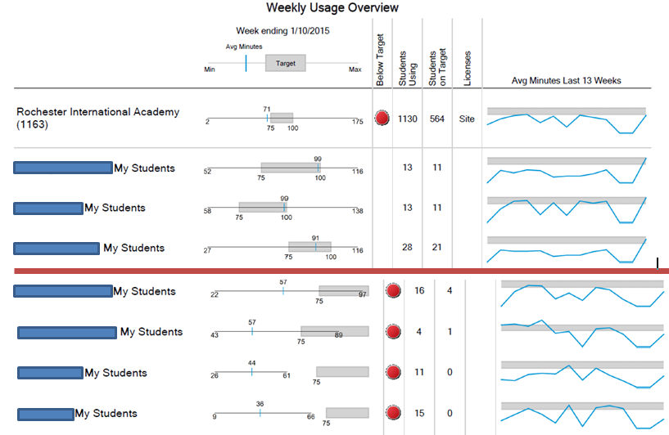

## Data Corner

This is the group weekly usage report for Imagine Learning that is emailed to RIA each Monday. Above the red line are the top three classes and below the red line are the bottom four classes (in regards to usage time). If you are interested in seeing if your class is on target, please see Jen Grimes. Please keep in mind that there is a report for each teacher (regardless of what you teach. For example, Haag has a report that has all students that are assigned to him in it.

## SLO Information

## This Month’s Danielson Rubric Component

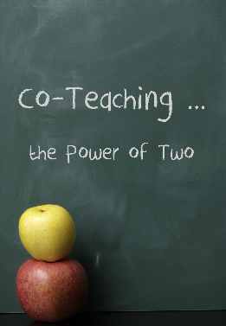

**February 13th is the deadline for Full Year course teachers to enter SLO targets into eDoctrina.** There is a second RTA dinner seminar scheduled for January 22nd for teachers to get more information about this process.   
**March 13th is the deadline for K-2, ESOL, Resource Room, Self-Contained, and Consult Teacher target entry, however, t**eachers of these subjects/grades should NOT enter data into eDoctrina until they are notified by Mary. Important information regarding these SLO’s is still being developed.   
If you have any questions please ask!

CoTeaching will be the focus of walk-throughs this month. Please be sure that you are coplanning with your colleagues in order to develop and present the best possible lessons for our students. All four domains of A Framework for Teaching are applicable to this focus.

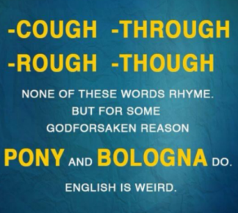

**NYS TESOL Journal**

We are pleased to announce that the ***NYS TESOL Journal***, a peer reviewed publication, is now available.  You can access our current issue (Volume 2, Issue 1) online at <http://www.journal.nystesol.org/currentissue.html>

[**Writing and the Common Core Series**](http://support.weta.org/site/R?i=ZaTqK8On_84HB7c1zCM_5w)

Teachers of ELLs often observe that writing is the last domain in which their students develop English language proficiency and that the pace at which ELLs develop writing proficiency has an impact on how soon students are able to exit language development programs in their schools. Teaching ELLs to write successfully in English is even more complex with the Common Core State Standards. In this three-part series for our blog, Diane Staehr Fenner and Ayanna Cooper offer an [**overview of the writing standards**](http://support.weta.org/site/R?i=CusYIKEn9L40s6_6DeuBcw) from an ELL perspective, discuss how [**culture impacts writing**](http://support.weta.org/site/R?i=x9mCogISOqYmES_PTjAPvw) (with a special look at students whose first language is Arabic), and walk through a [**writing prompt**](http://support.weta.org/site/R?i=4YiABVV7rOn9JWHgyUoRPA) with ideas for scaffolding the assignment. If you read this sentence send an email to Jen Grimes with ‘I found it’ in the subject line! Shhh, don’t tell!

<http://blog.colorincolorado.org/2013/05/17/writing-with-the-common-core-considerations-for-ells/>

**University of Rochester Professional Development**

We are very excited to offer two professional learning experiences, at NO COST, to K-12 math and ESOL teachers, coaches, paraprofessionals, and school leaders over the February 2015 recess!   New York State’s education department recently stated that “*ALL* teachers are teachers of ELLs” and new requirements are coming that require all students receive ESOL support in all content areas.  Each of these three-day institutes, divided into K-5 and 6-12 grade bands, are designed and taught by a team of math and ESOL educators to support all students’ learning *of* mathematics while focusing on each students’ learning of language *through* mathematics.

Details about each of the institutes can be found on the attached flyer.  Each institute offers 20 professional development hours with no registration costs!  And, since they are offered over the February recess there is no need for sub plans!  Come relaxed and ready to dive in!!   Registration is on a first-come, first-served basis (please register through the attached flyer).

These opportunities are funded by the Western NY Collaboration for ELL Success (Project CELLS), through a grant awarded by the U.S. Department of Education’s Office of English Language Acquisition.

Stephanie Martin

Co-Director of Mathematics Education Outreach

Center for Professional Development and Education Reform

Warner Graduate School of Education

University of Rochester

348 LeChase Hall, PO Box 270425, Rochester, NY 14627-0425

585-319-9294

[smartin@warner.rochester.edu](mailto:smartin@warner.rochester.edu)

## Instructional/Professional Resources

RIA POST

Page 4

Isn’t English funny?!...

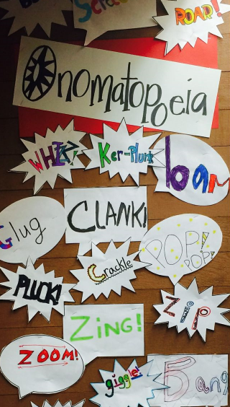

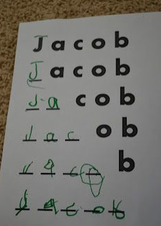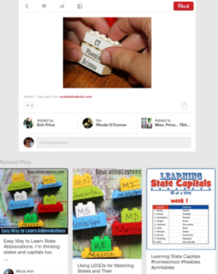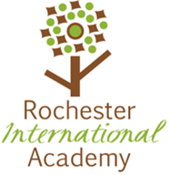

* Jess Mellenthine for replacing the bulletin board display in the back hallway by her classroom!
* Jill Harris, Alicia Castellon, Lisa Watson, and Julianne Wise for attending Pippin with Mary and our students on Wednesday evening (and late night)
* Annie Tran, Cassie Miller, and Katie Sweet for consistently updating their digital TANs
* Corey Skinner for preparing the MAC Lab! Please sign up outside of Jen’s office to use the lab

## Shout Outs to…

Teaching spelling

Using LEGOS to teach concepts

A fun idea for teaching ONOMATOPOEIA

**Rochester International Academy**

1 Edgerton Park

Rochester, NY 14608

**Phone:**

(555) 324-5250

**Fax:**

(555) 324-5251

**Website:  
www.rcsdk12.org/ria**