**Learning to Share**

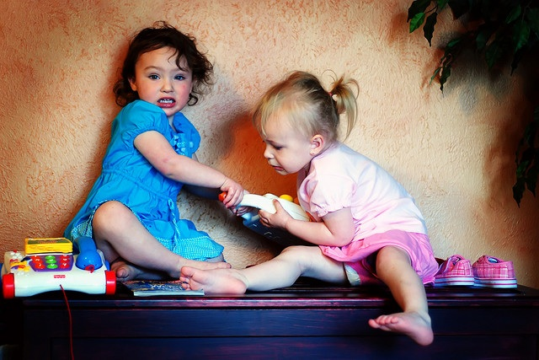

*The best way to prepare for life is to begin to live.  
-Elbert Hubbard*

In her book [**The Insightful Teacher**](http://mail.ccie.com/go/eed/14186)**,** Nancy Bruski offers this insight about sharing in the preschool classroom:  
  
"It is necessary for young children to learn how to cooperate in the use of classroom materials; however, sharing often involves giving up what one has so that someone else can have it, and this is very difficult for young children. Children become attached to things they invest themselves in, whether it be toys, materials, ideas for play, or being the first in line. Sharing is challenging and something that is learned slowly.  
  
"Some children seem to have an easier time sharing than others, but the child who is more possessive is not being bad or difficult. Wanting to keep the teacher's attention or to play with the favored red fire truck is normal on the part of children, and their feelings should be treated as such.  
  
"Our early childhood program found a solution to this type of problem that worked extremely well...If a child chose something to play with in the classroom, he could keep it as long as he wanted, even if he played with it during the entire free-choice time. If he needed to go to the bathroom and was not finished playing with the toy, he could ask the teacher to watch it for him, so that no one else could play with it. However, if a child left a toy or play material to go to another part of the room and do something else, then the toy or material was open for anyone else to play with."