Pre-K Deaf/HH Resource Calendar May 25-29
 | Monday | Tuesday | Wednesday | Thursday | Friday
Daily  Listening Check  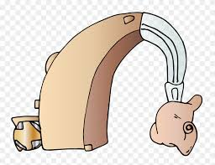 | Look at your hearing aid and make sure the battery is working.  Look at your earmold and make sure it is clean. Put your hearing aid on and talk to yourself. If you can hear, it’s working! If not, change the battery. Put it on and keep it on! | Check your hearing aid to make sure it is working.  Put it on and keep it on!  Changing a Hearing Aid Battery for Kids  Click on the link! | Check your hearing aid to make sure it is working.  Put it on and keep it on! | Check your hearing aid to make sure it is working.  Put it on and keep it on! | Check your hearing aid to make sure it is working.  Put it on and keep it on!
Self-advocacy | What should you or your teacher do with your microphone at the end of the school day? | Terrific Tuesday! Help someone have a terrific Tuesday! Write that person a note using the following sentence starters.  I think you are talented at...  Thank you for...  I think you are awesome because... | Name 3 places that you should wear your hearing aids. | Names 3 places that you should NOT wear your hearing aids. | Answer the following questions:  Who is your teacher of the Deaf?  Who is your audiologist?  Who is your classroom teacher?
Kindergarten Readiness  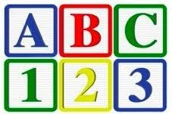 | Hop on one foot and sing your ABC’s!  Record yourself and send it to your TOD if you’d like! | Letter P Song and Signs  Click on the link! | Letter Q Song and Signs  Click on the link! | Letter R Song and Signs  Click on the link! | See It, Say It, Sign It  Click on the link!

