** Free Learning Websites** 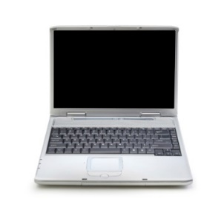

**Starfall** [www.starfall.com](http://www.starfall.com) (primary grades)

**ABC Mouse** [www.abcmouse.com](http://www.abcmouse.com/Reading) (free 30 day trial)

**Highlights Kids** http://www.highlightskids.com

**PBS Kids** www.pbskids.org

**Garfield Phonics** <http://www.professorgarfield.com/phonics/fishing/fishing.html>

**Compass** <https://compass.rcsdk12.org> (login needed-child’s teacher can provide this)

**ABCYA** <http://www.abcya.com/> (Grades Pre-K – 5)

**BrainPop** <http://www.brainpop.com/> (Login = ps52student Password = student)

**Proof Reading** <http://www.eduplace.com/kids/hme/k_5/proofread/> (Grades 3-6)

**International Chidren’s Digital Library** <http://en.childrenslibrary.org/>

**StorylineOnline** <http://www.storylineonline.net/>

**Seussville** <http://www.seussville.com/>

**National Geographic for Kids**  http://kids.nationalgeographic.com/

**Switcheroo Zoo** <http://switcheroozoo.com/>

**Into the Book** <http://reading.ecb.org/>

**Fun Brain** <http://www.funbrain.com/>

**Scholastic**  http://www.scholastic.com/home/

**Home Reading Program: Pizza Hut Book It**  <http://bookitprogram.com/>