**NAME ___________________________ Period ___________**

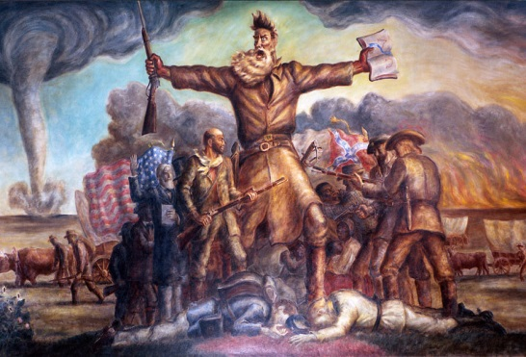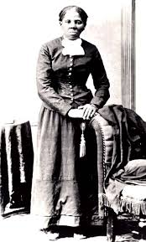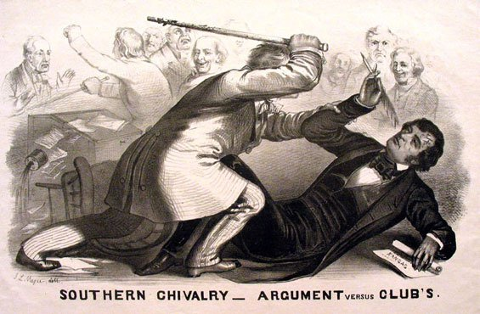

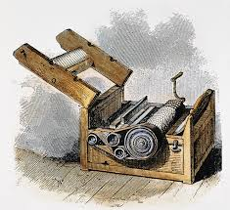

***AP US HISTORY***

**Winter Break Project Packet**

There are six parts of this project. All must be completed by the end of break. This project is worth 4 test grades. This can make or break your grade this marking period!

1. American Pageant Ch 16 – 19 Questions _____________/200
2. American Pageant Essay Outline #1 _____________/50
3. American Pageant Essay Outline #2 _____________/50
4. America: The Story of Us Video Questions _____________/50
5. Narrative Life of Frederick Douglas Reading _____________/25
6. Two Viewpoints on Slavery Reading _____________/25
7. Extra Credit Essay outline _____________
8. Extra Credit Picture Identification _____________

**TOTAL_____________/400**

**Extra Credit Picture Identification:**

|  |  |
| --- | --- |
| Describe the Picture.    What is its significance? | Describe the Picture.    What is its significance? |
| Describe the Picture.    What is its significance? | Describe the Picture.    What is its significance? |

**CHAPTER 16: THE SOUTH AND THE SLAVERY CONTROVERSY**

1. What happened to slavery as a result of the cotton gin?
2. What were the characteristics of the southern aristocracy?
3. What was the impact of plantation agriculture on the land?
4. What were the weaknesses of the slave plantation system?
5. What was immigration to the south limited?
6. Who made up a majority of the population of white southerners?
7. Who owned most of the slaves by the mid-1800s?
8. Who were the most pro-Union of the white southerners?
9. Why did slave-less whites support the slavery system?
10. What was typical of northern attitudes towards free blacks?
11. What happened to the South's economy based on the slavery system?
12. What was one of the most upsetting aspects of the slave trade and the theme of *Uncle Tom's Cabin?*
13. Where were most slaves concentrated in the South?
14. What was life like for slaves in the South?
15. What are some examples of slave uprisings in the South?
16. What were views of the following people: William Lloyd Garrison, Theodore Dwight Weld, Frederick Douglass?
17. What were the arguments of the South in favor of slavery?  The North against slavery?

**CHAPTER 17: MANIFEST DESTINY AND ITS LEGACY, 1841-1848**

1. Why did John Tyler join the Whig party?  Why did Whigs include him on their ticket?
2. What was the impact of Tyler's bank veto?
3. What were the arguments for and against annexing Texas? Why was it finally admitted?
4. Why did many US settlers head to Oregon?
5. What was the platform for Polk's democratic candidacy in 1844?
6. What was the area in dispute in Oregon?  With whom?
7. What was the belief that God had ordained that America control the land from the Atlantic to the Pacific?
8. Who were the candidates in 1844?  Issues?
9. Why did the United States go to war with Mexico?
10. What was the result of the Mexican-American War? Terms of the Treaty of Guadelupe-Hildalgo?
11. What was the Wilmont Proviso? Impact?

**CHAPTER 18: RENEWING THE SECTIONAL STRUGGLE**

1. What did national parties often do to maintain national unity in regards to the slavery issue?
2. What was the impact of the Mexican War on the slavery issue?
3. What were the beliefs of the Free Soil Party?
4. What does the term "popular sovereignty" mean?
5. What was the key issue in the election of 1848?
6. What event brought turmoil to the presidency of Zachary Taylor?
7. Why did the Free Soilers condemn slavery?
8. What was Calhoun's plan to protect the South?
9. What were the major events during the debates of 1850?
10. What were the terms of the Compromise of 1850? Reaction from the North and the South?
11. What happened to the Whigs in 1852?
12. How was slavery impacted by the push for a transcontinental railroad?
13. How did Douglas propose to address slavery in Kansas and Nebraska?

**CHAPTER 19: DRIFTING TOWARDS DISUNION, 1854-1861**         

1. What was described in *Uncle Tom's Cabin?* Impact domestically? Impact abroad?
2. What was bleeding Kansas? Why did this occur?
3. What were the major events of "Bleeding Kansas?"
4. What did the caning of Sumner exemplify?
5. Who were the candidates in the election of 1856?
6. What was the main platform idea of the Know-Nothings?
7. Why did the Republicans lose the election in 1856?
8. Explain the *Dred Scott* decision? Impact?
9. What were the major points of the Lincoln-Douglas debates?
10. What was the South's reaction to Harper's Ferry?
11. What were the political platforms of the candidates for office in 1860?
12. What were the results of the election of 1860?
13. How did the lame duck Buchanan act before Lincoln took office?
14. Why did the Southern states secede from the Union?

**Possible Essay Topics for (Unit Five) Chapters 14 to 19:**

**(Pick two ond write a brief Essay outline)**

1. Analyze the ways in which supporters of slavery in the nineteenth century used legal, religious, and economic arguments to defend the institution of slavery.
2. Assess the moral arguments and political actions of those opposed to the spread of slavery in the context of TWO of the following:
   1. Missouri Compromise c. Compromise of 1850
   2. Mexican War d. Kansas-Nebraska Act
3. Discuss the impact of territorial expansion on national unity between 1800 and 1850.
4. Evaluate three of the following events and the role they played in the period before the Civil War
   1. Missouri Compromise of 1820 c. Kansas-Nebraska Act
   2. Dred Scott Case d. John Brown’s Raid at Harpers Ferry
5. Assess how Manifest Destiny in Combination with the slavery issue contributed to session and the Civil War
6. Some historians argue that slavery was the primary cause of the Civil War. Explain to what extent you agree with this. (time period: 1846-1860)

**#_______Essay Outline**

*Introduction:*

*Thesis (Argument)*

**#_______ Essay Outline**

*Introduction:*

*Thesis (Argument)*

***America: The Story of Us* Episode 4: “Division”**

Directions: Answer questions from the video. [www.rcsdk12.org/stem/tobin](http://www.rcsdk12.org/stem/tobin) (Click on AP US videos for the link)

1. The _____________ ____________ is the largest construction job in North America in the past 400 years.
2. How long did it take to build the Erie Canal? How many lives were lost? How?
3. What word was invented in 1840?
4. What is cotton’s nickname?
5. Cotton loom machines are at the basis of what technology?
6. What oil was used before crude oil, to fuel lamps and lube machines?
7. What was ‘unique’ about the whaling industries hiring and promotion practices?
8. Why were young, light skin, female virgins the most frequently bought slaves?
9. What were common punishments for runaway slaves if they were caught?
10. Describe Frederick Douglas
11. What was the bounty on Harriet Tubman’s head for being the leader of the Underground Railroad?
12. In 1850 what law made the search for runaway slaves a ‘witch hunt’?
13. In 1852: What novel, written by Harriet Beecher Stowe, becomes the 2nd biggest selling book after the Bible that showed the Northerners true insight into slavery?
14. Describe John Brown
15. December 20, 1860: What was the first state to secede from the Union?
16. Abraham Lincoln received his first death threat before ever taking office. He saved all his death threats in a file he named____________________.
17. How many weeks after Lincoln takes office are the first shots of the Civil War fired?