Name ___________________ Exit Ticket

Ms. Megan Find the Roots

Factor and find the roots:

1. 2.

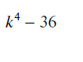 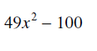

3. 4.

